Tela de Atualização do Cliente (9130)

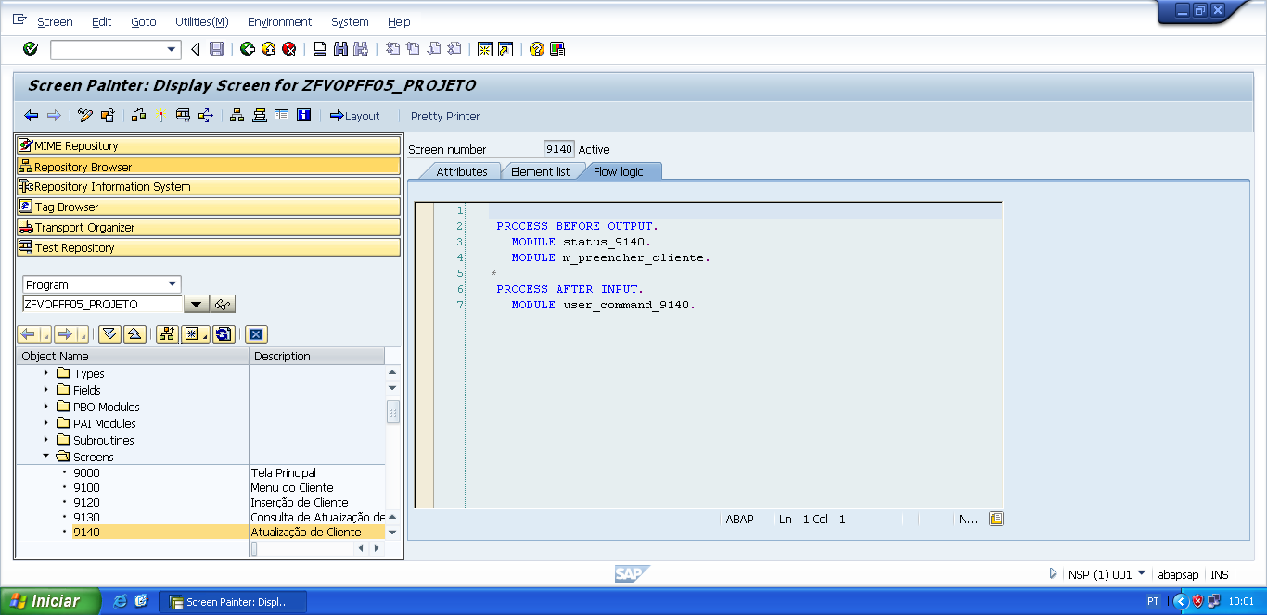

PROCESS BEFORE OUTPUT.  
   MODULE status_9140.  
   MODULE m_preencher_cliente.

*&---------------------------------------------------------------------*  
*&      Module  STATUS_9140  OUTPUT  
*&---------------------------------------------------------------------*  
*       text  
*----------------------------------------------------------------------*  
MODULE status_9140 OUTPUT.  
  SET PF-STATUS 'STATUS9140'.  
  SET TITLEBAR 'TITULO9140'.  
  
ENDMODULE.                 " STATUS_9140  OUTPUT

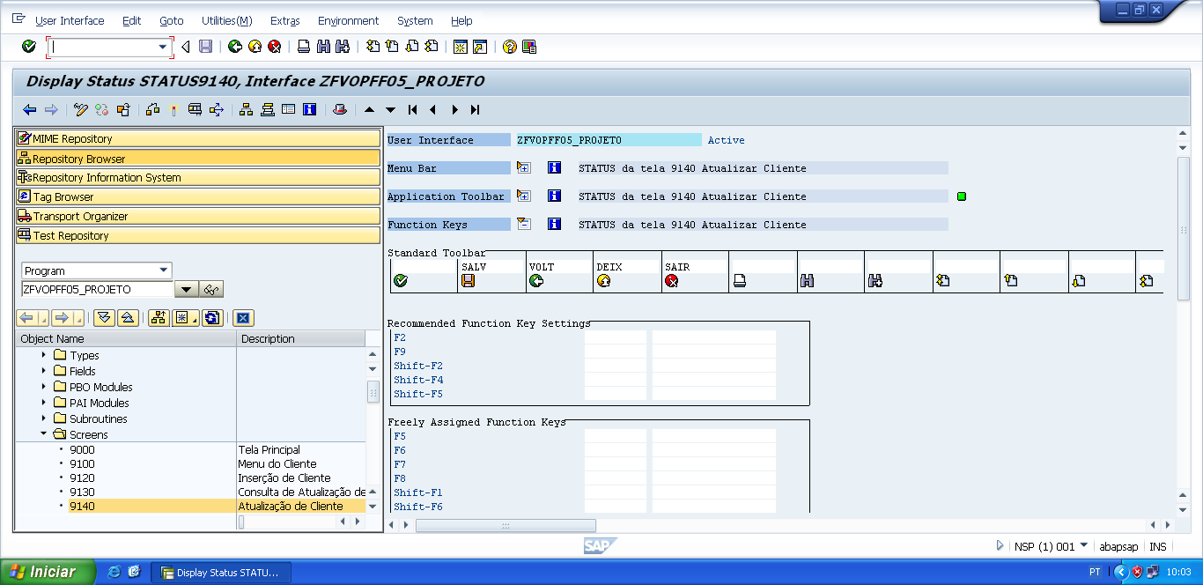

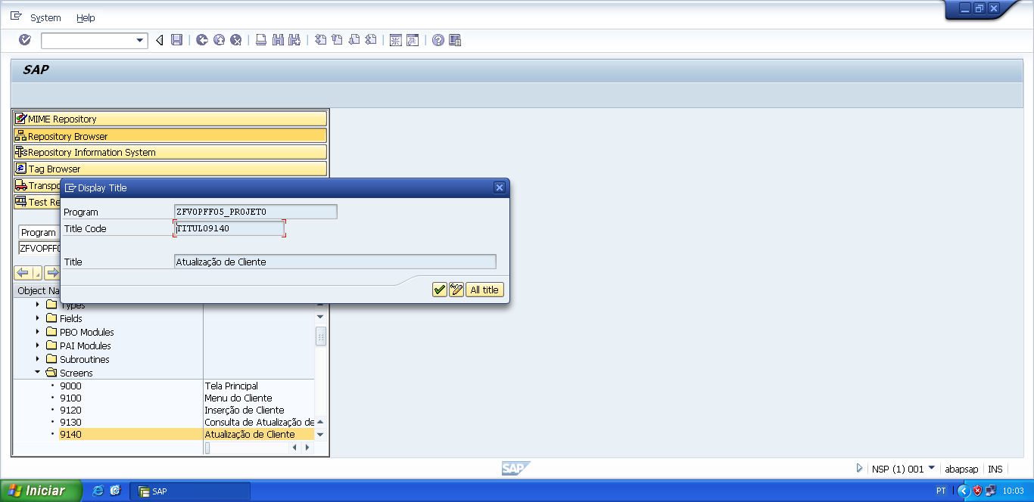

*&---------------------------------------------------------------------*  
*&      Module   OUTPUT  
*&---------------------------------------------------------------------*  
*       text  
*----------------------------------------------------------------------*  
MODULE m_preencher_cliente OUTPUT.  
  
PERFORM f_preencher_cliente.  
  
  
ENDMODULE.                    "m_preencher_cliente

*&---------------------------------------------------------------------*  
*&      Form  F_PREENCHER_CLIENTE  
*&---------------------------------------------------------------------*  
*       text  
*----------------------------------------------------------------------*  
*  -->  p1        text  
*  <--  p2        text  
*----------------------------------------------------------------------*  
FORM f_preencher_cliente .  
  
  v_nome_cli     = wa_zfvtpff05_client-nome_cliente.  
  v_end_cli      = wa_zfvtpff05_client-end_cliente.  
  v_tel_pri_cli  = wa_zfvtpff05_client-tel01_cliente.  
  v_tel_sec_cli  = wa_zfvtpff05_client-tel02_cliente.  
  
ENDFORM.                    " F_PREENCHER_CLIENTE

PROCESS AFTER INPUT.  
   MODULE user_command_9140.

*&---------------------------------------------------------------------*  
*&      Module  USER_COMMAND_9140  INPUT  
*&---------------------------------------------------------------------*  
*       text  
*----------------------------------------------------------------------*  
MODULE user_command_9140 INPUT.  
  
  v_okcode = sy-ucomm.  
  
  CASE v_okcode.  
    WHEN 'VOLT'.  
      PERFORM f_voltar.  
    WHEN 'DEIX'.  
      PERFORM f_deixar.  
    WHEN 'SAIR'.  
      PERFORM f_sair.  
    WHEN 'SALV'.  
      PERFORM f_salvar_atualizacao_cliente.  
*  
    WHEN 'SAL4'.  
      PERFORM f_salvar_atualizacao_cliente.  
  ENDCASE.  
  
  CLEAR v_okcode.  
ENDMODULE.                 " USER_COMMAND_9140  INPUT

*&---------------------------------------------------------------------*  
*&      Form  F_VOLTAR  
*&---------------------------------------------------------------------*  
* FORM de voltar, serve para voltar automaticamente para a tela  
*anterior da tela atual.  
*----------------------------------------------------------------------*  
*  -->  p1        text  
*  <--  p2        text  
*----------------------------------------------------------------------*  
FORM f_voltar.  
  
*Volte para á tela 9000 (Tela Principal)  
*ou  
**CALL SCREEN '9000'.**  
  PERFORM f_limpar_variaveis.  
  SET SCREEN 0.  
  LEAVE SCREEN.  
  
  
ENDFORM.                    " F_VOLTAR  
  
*&---------------------------------------------------------------------*  
*&      Form  F_DEIXAR  
*&---------------------------------------------------------------------*  
*       text  
*----------------------------------------------------------------------*  
*  -->  p1        text  
*  <--  p2        text  
*----------------------------------------------------------------------*  
FORM f_deixar .  
  
  LEAVE LIST-PROCESSING.  
  
ENDFORM.                    " F_DEIXAR  
  
*&---------------------------------------------------------------------*  
*&      Form  F_SAIR  
*&---------------------------------------------------------------------*  
*       text  
*----------------------------------------------------------------------*  
*  -->  p1        text  
*  <--  p2        text  
*----------------------------------------------------------------------*  
FORM f_sair.  
  
  LEAVE LIST-PROCESSING.  
  
ENDFORM.                    " F_SAIR

*&---------------------------------------------------------------------*  
*&      Form  F_SALVAR_ATUALIZACAO_CLIENTE  
*&---------------------------------------------------------------------*  
*       text  
*----------------------------------------------------------------------*  
*  -->  p1        text  
*  <--  p2        text  
*----------------------------------------------------------------------*  
FORM f_salvar_atualizacao_cliente .  
  
  UPDATE zfvtpff05_client  
       SET  cpf_cliente    = v_cpf_cli  
            nome_cliente   = v_nome_cli  
            end_cliente    = v_end_cli  
            tel01_cliente  = v_tel_pri_cli  
            tel02_cliente  = v_tel_sec_cli  
       WHERE cpf_cliente   = v_cpf_cli.  
*  
  IF sy-subrc IS INITIAL.  
*  
    PERFORM f_limpar_variaveis.  
    MESSAGE s005(zfvclpff05).  
    CALL SCREEN '9130'.  
*  
  
  ELSE.  
    MESSAGE i009(zfvclpff05).  
  ENDIF.  
  
  
ENDFORM.                    " F_SALVAR_ATUALIZACAO_CLIENTE

*&---------------------------------------------------------------------*  
*&      Form  F_LIMPAR_VARIAVEIS  
*&---------------------------------------------------------------------*  
*       text  
*----------------------------------------------------------------------*  
*  -->  p1        text  
*  <--  p2        text  
*----------------------------------------------------------------------*  
FORM f_limpar_variaveis.  
  
*limpar as variaveis usadas nas telas  
  CLEAR: v_cpf_cli,  
         v_nome_cli,  
         v_end_cli,  
         v_tel_pri_cli,  
         v_tel_sec_cli.  
*  
  CLEAR: v_cnpj_forn,  
         v_nome_forn,  
         v_end_forn,  
         v_tel_pri_forn,  
         v_tel_sec_forn.  
*  
  CLEAR: v_chassi_car,  
         v_modelo_car,  
         v_ano_car,  
         v_cor_car.  
  
  CLEAR: wa_zfvtpff05_client,  
         wa_zfvtpff05_fornec,  
         wa_zfvtpff05_carro.  
  
ENDFORM.                    " F_LIMPAR_VARIAVEIS

